**Histogram Equalization and CLAHE (**Contrast Limited Adaptive Histogram Equalization ) **to improve contrast in images :**

**→ Histogram Equalization :**

Histogram Equalization is a **computer image processing technique used to improve contrast in images** . This allows for areas of lower local contrast to gain a higher contrast. ... A color histogram of an image represents the number of pixels in each type of color component.

**→ CLAHE :**

**Contrast Limited Adaptive Histogram Equalization (CLAHE)** to equalize images. CLAHE is a variant of Adaptive histogram equalization (AHE) which takes care of over-amplification of the contrast. CLAHE operates on small regions in the image, called tiles, rather than the entire image. The neighboring tiles are then combined using bilinear interpolation to remove the artificial boundaries.  
This algorithm can be applied to improve the contrast of images.

**→ HISTOGRAM EQUALIZATION :**

1. **Read our image :**

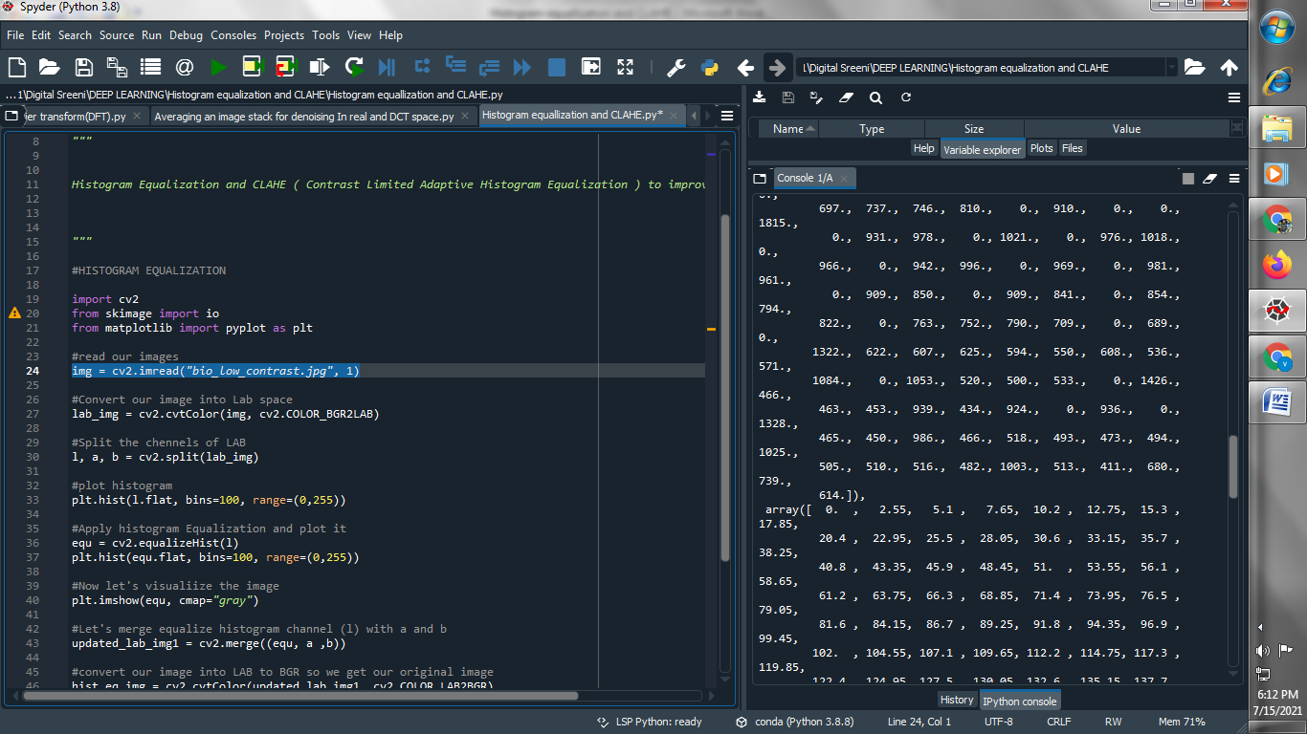

1. **Convert our image into LAB space :**

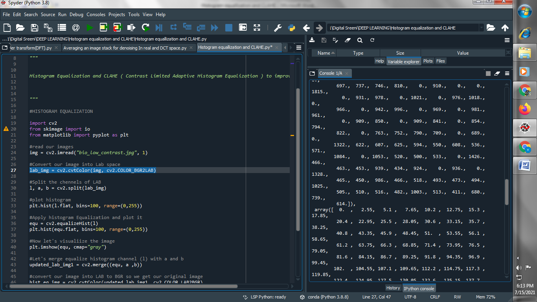

**(3) Split the channels of LAB :**

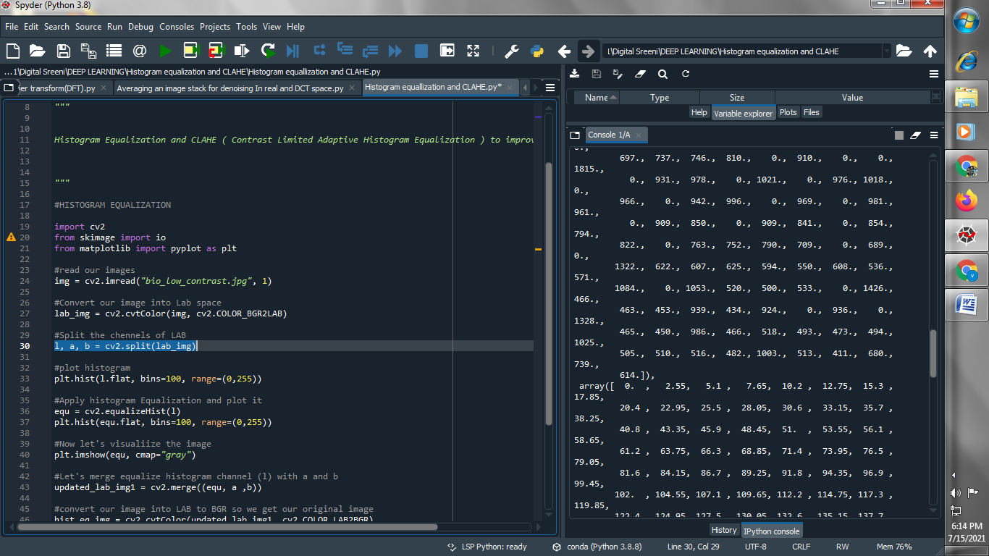

**(4) Plot Histogram :**

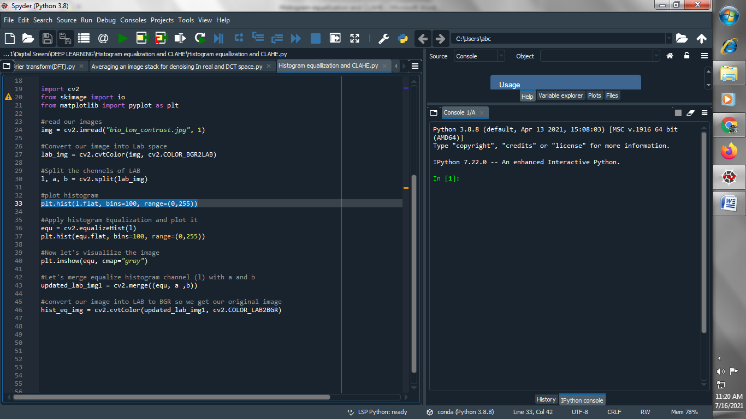

**Output :**

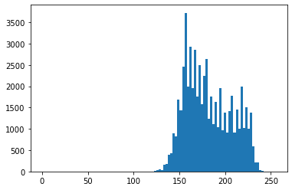

**(5) Apply histogram Equalization and plot it :**

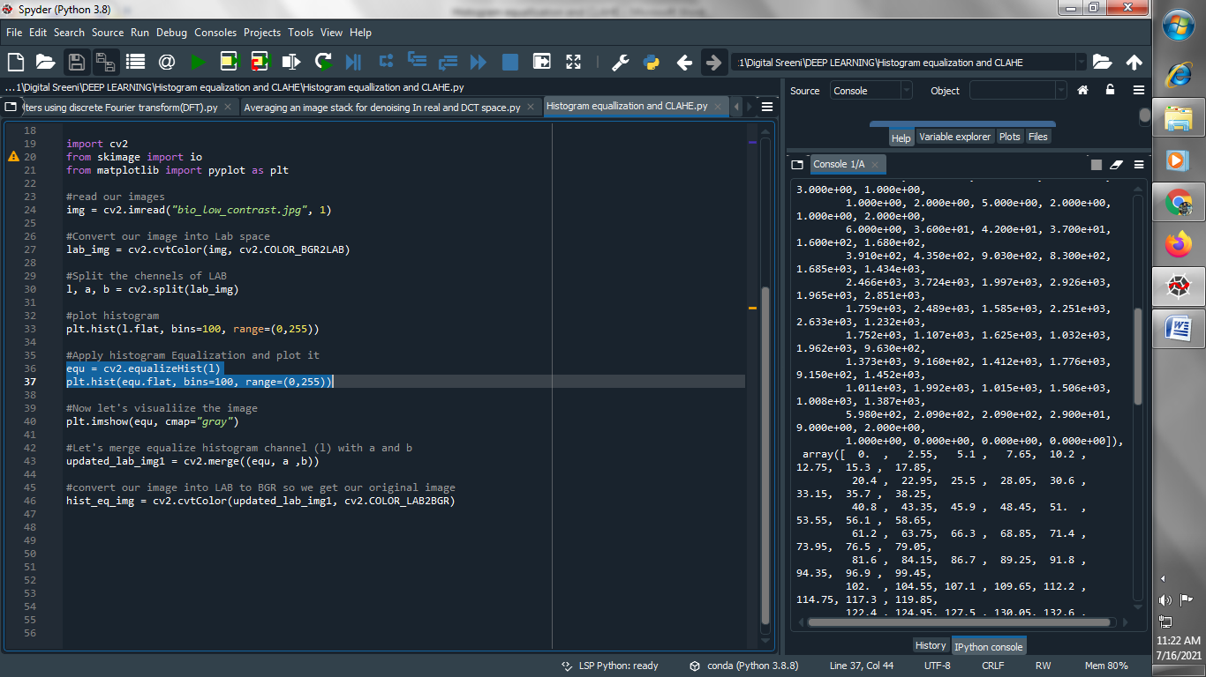

**Output :**

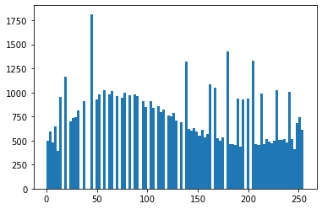

**(6) Let’s Visualize the image :**

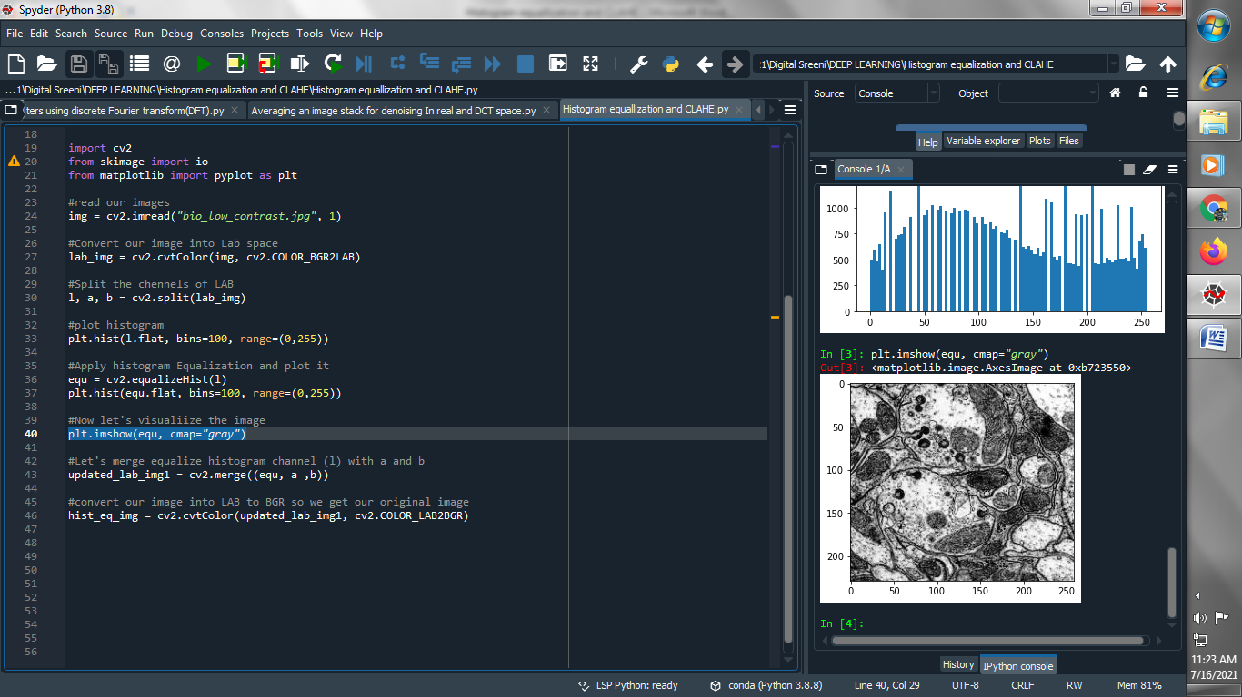

**Output :**

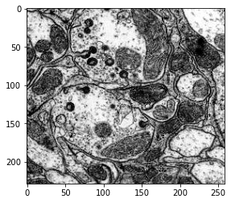

**(7) Let's merge equalize histogram channel (l) with a and b :**

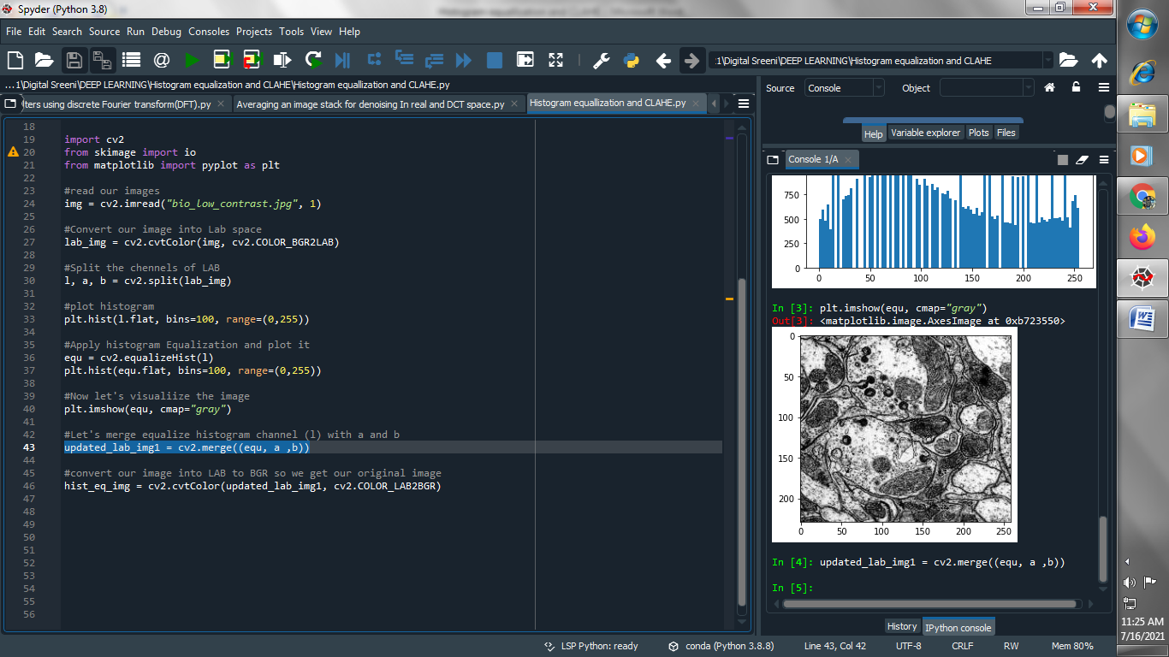

**(8) convert our image into LAB to BGR so we get our original image**

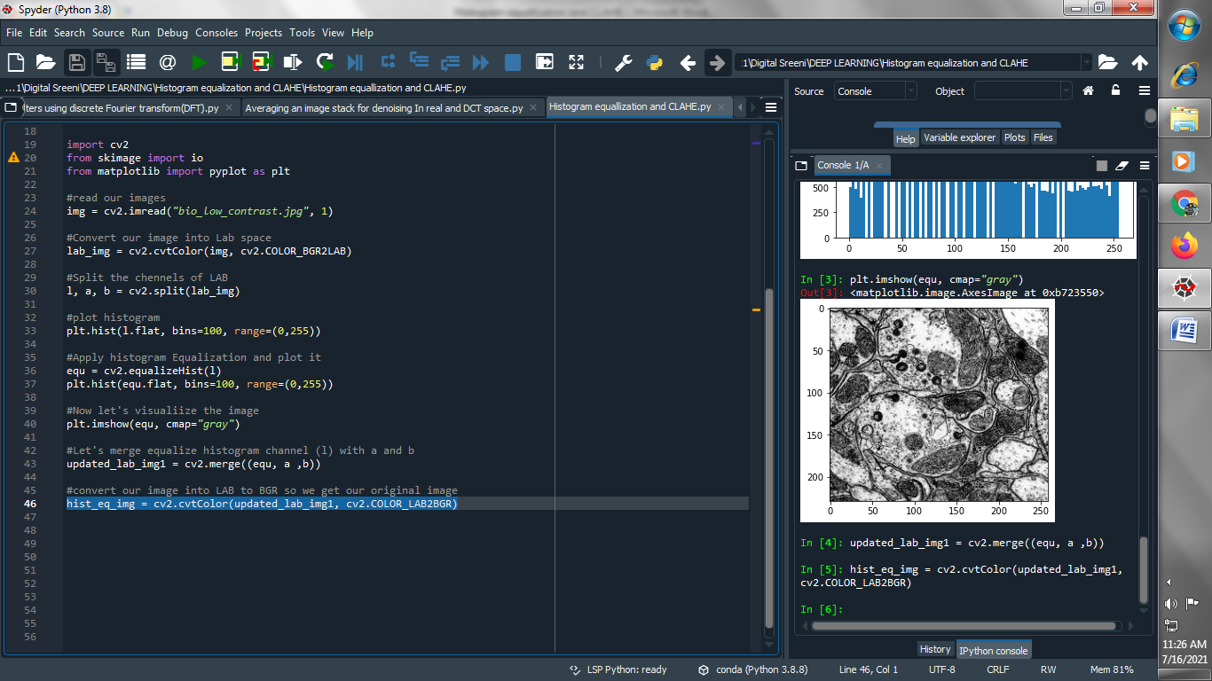

**(9) Apply CLAHE to L channel :**

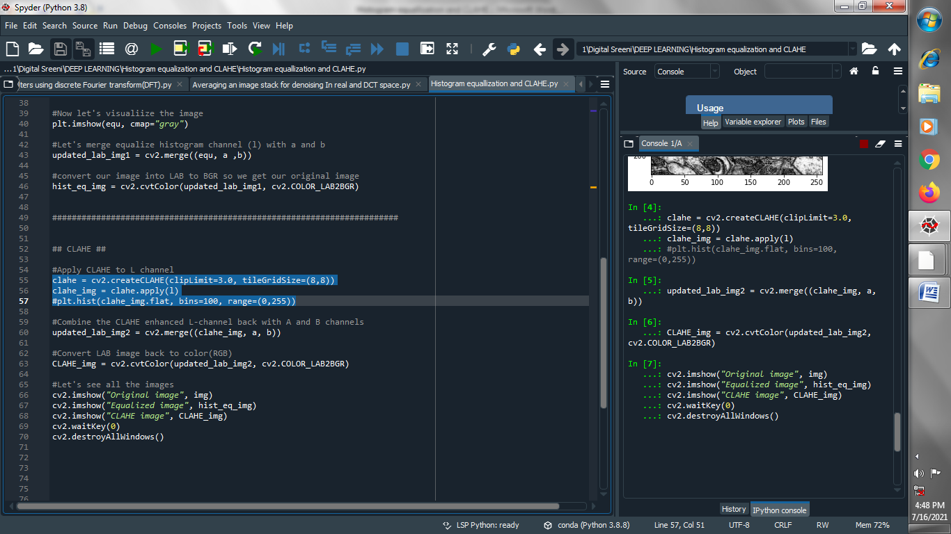

**(10) Combine the CLAHE enhanced L-channel back with A and B channels :**

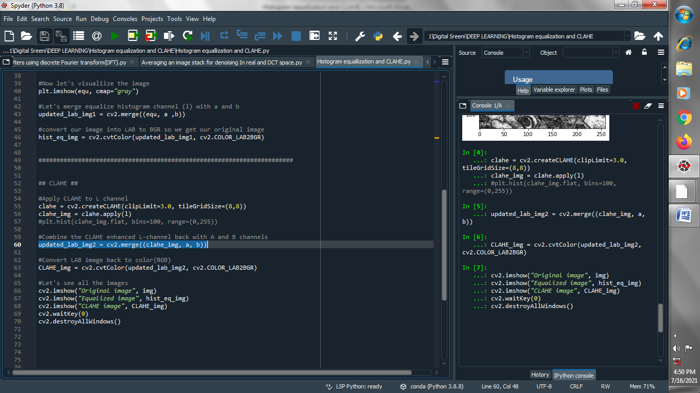

**(11) Convert LAB image back to color(RGB) :**

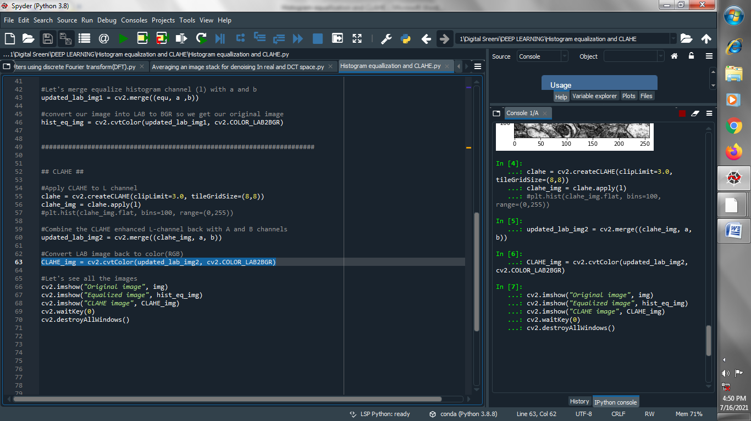

**(12) Let’s see all the images :**

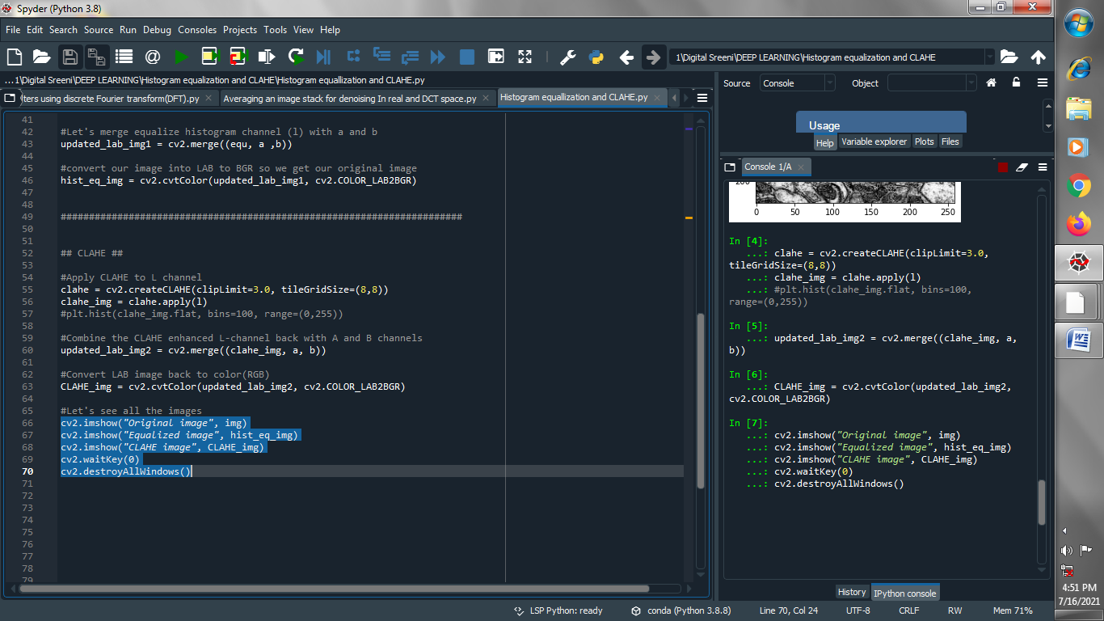

**Output :  
Original image :**

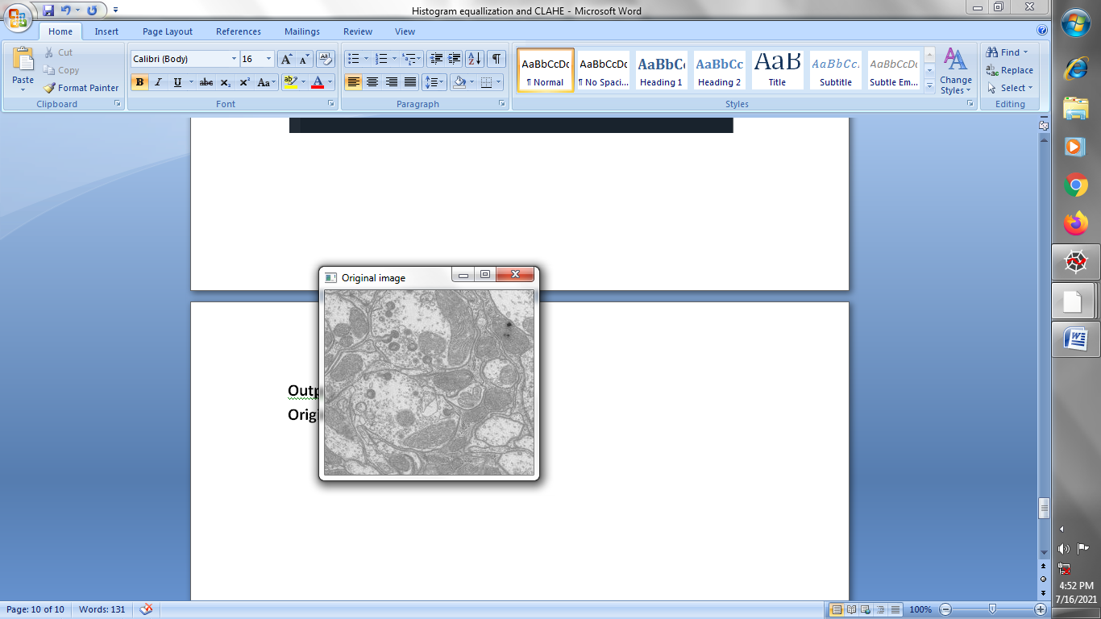

**Equalized image :**

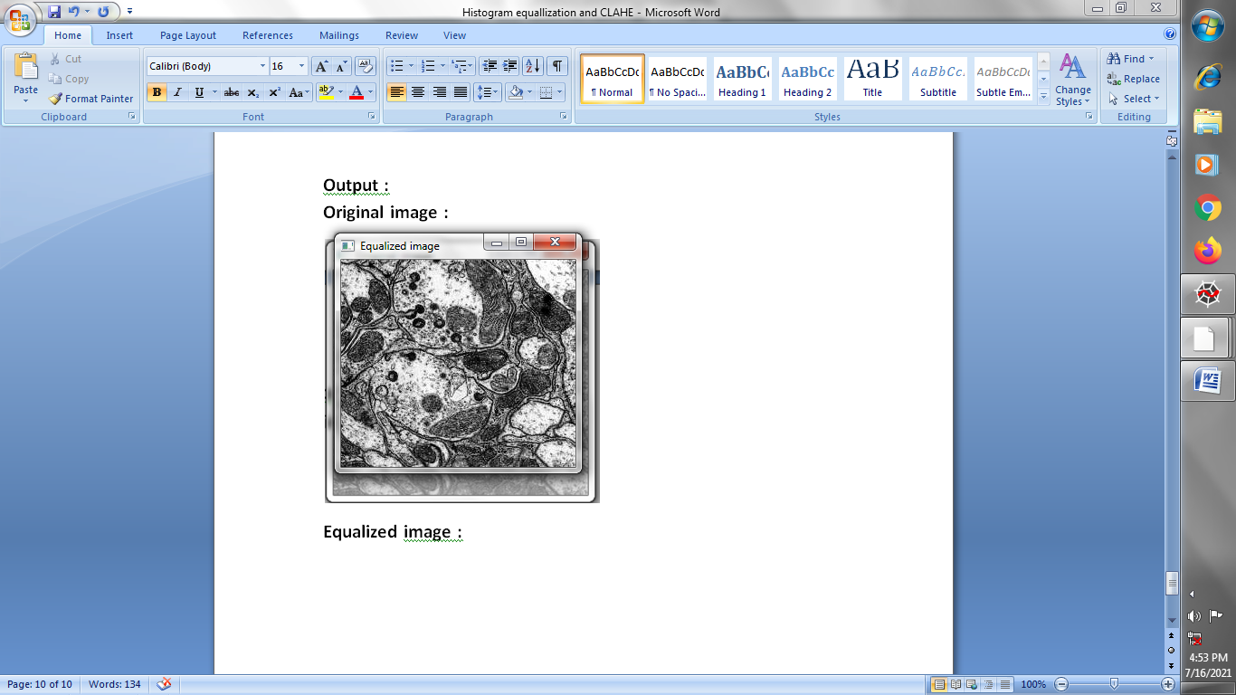

**CLAHE image :**

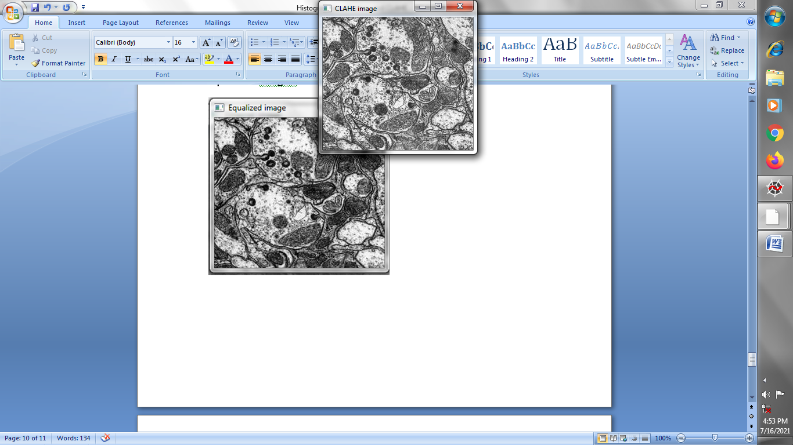

**→ Let’s perform all above thing on different image :**

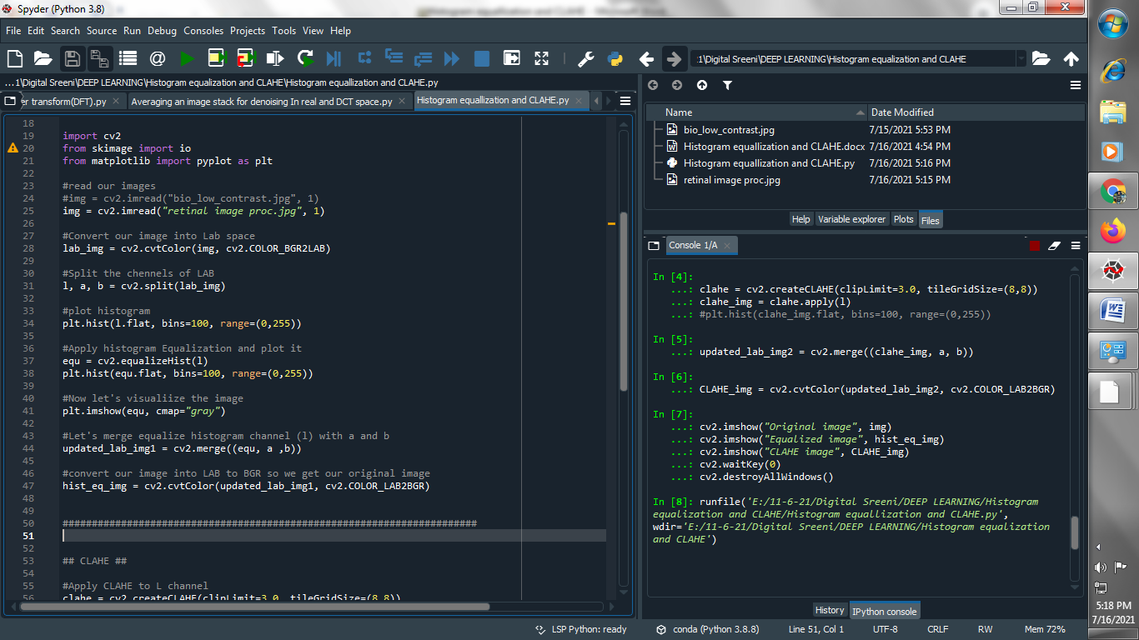

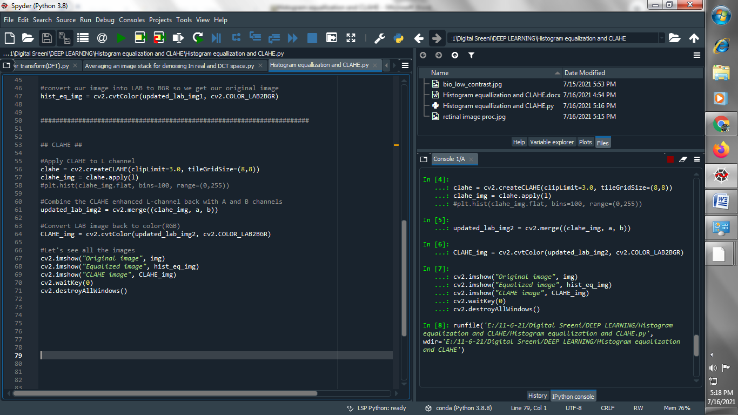

**Output :**

**Original image :**

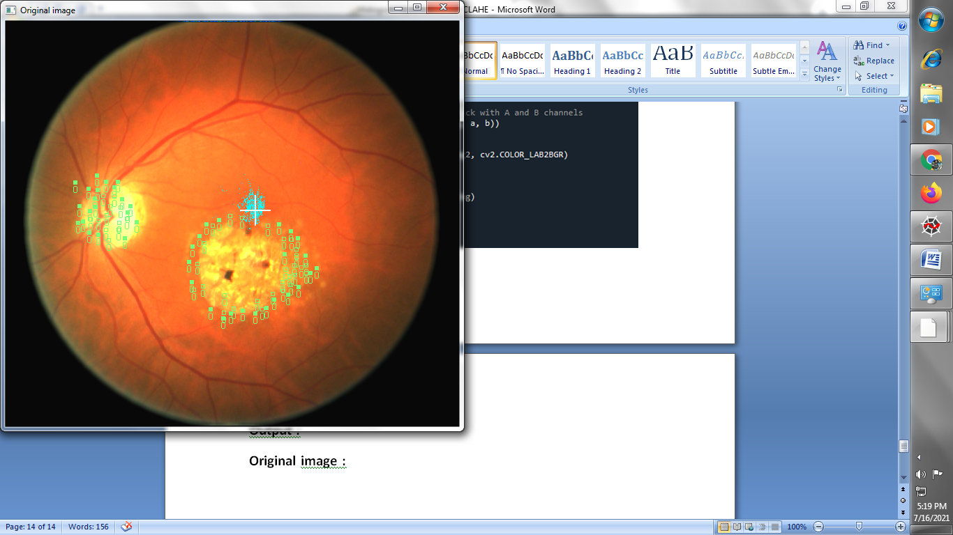

**Equalized image :**

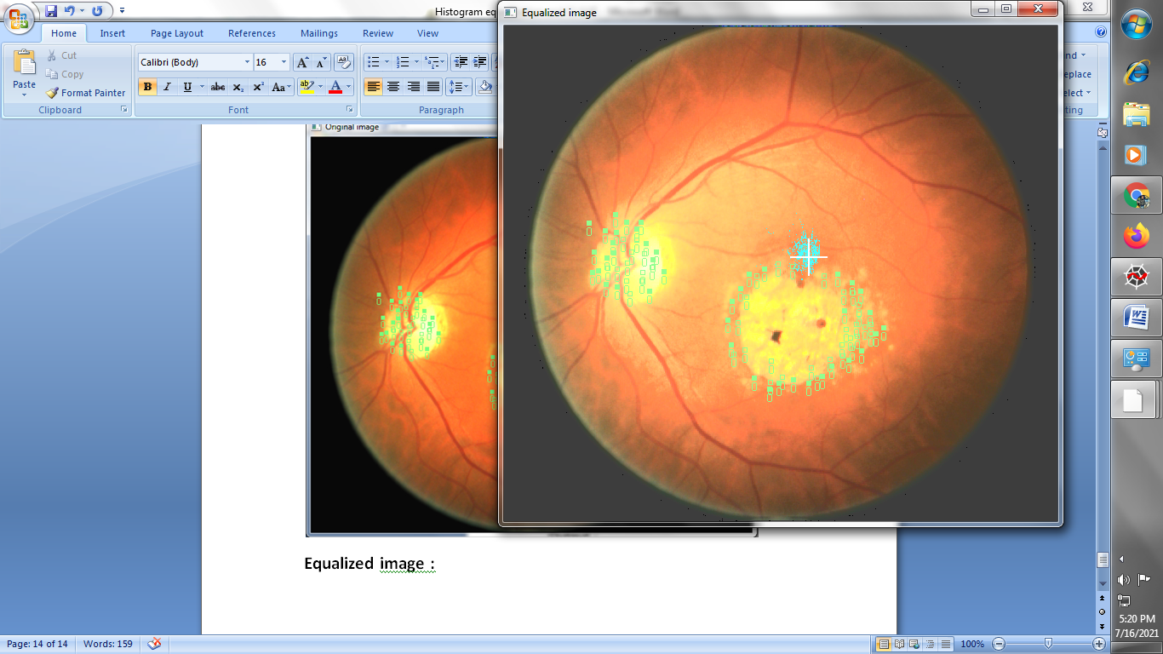

**CLAHE image :**

